Design and Implementation of a RISC-V Based SoC Subsystem with AXI Interconnect for Embedded Application

1.1 What is RISC-V?
RISC-V is a free, open-source instruction set architecture developed at UC Berkeley in 2010, based on the RISC philosophy of simplicity and efficiency. It uses a modular design with a base instruction set (RV32I/RV64I) and making it suitable from microcontrollers to high-performance systems. Its open nature (no license or royalty) and design flexibility make it ideal for RTL design, research, and custom SoC development.

SoC Subsystem Architecture
PicoRV32
RV32I CPU
clk / resetn
mem_valid
mem_ready
mem_addr[31:0]
mem_wdata[31:0]
mem_rdata[31:0]
AXI Bridge
mem→AXI-Lite
FSM
AXI-Lite Bus (32-bit)
AXI
Decoder
addr → one-hot
ROM
0x0000_0000
64 KB
SRAM
0x0001_0000
64 KB
UART AXI
0x1000_0000
UART TX
8N1 serial
uart_tx
PIN
External Ports:
clk reset uart_tx uart_rx
Legendd:
PicoRV32 CPU
AXI Bus
AXI Decoder
ROM
SRAM
AXI
Decoder
addr → one-hot
UART

2.1 Prerequisites
- Download and extract the project folder (RTL, testbench, firmware, scripts), then set up a Linux environment to build and simulate using provided Makefiles Google Drive Link.
- Install required tools: RISC-V GCC Toolchain, Verilator or Icarus Verilog, and GTKWave, and verify installation via command line.
- Ensure basic knowledge of Digital Electronics, Computer Architecture, Verilog HDL, RISC-V architecture, AXI/AXI-Lite protocols, and Linux-based simulation workflow.

2.2 Component Descriptions
The following describes the major components and their role in the system data flow:

CPU (PicoRV32 Core)
The PicoRV32 core is the primary computation engine of the SoC. It fetches instructions from the ROM at reset, decodes them using the RV32I instruction decoder, and executes them through its ALU. On encountering load/store instructions, it drives the memory interface to perform read or write operations. The CPU communicates with all peripheral devices exclusively through memory-mapped addresses on the AXI bus. Its memory interface outputs include mem_valid (transaction request), mem_addr (32-bit address), mem_wdata (write data), mem_wstrb (byte enables), and captures mem_rdata (read data) and mem_ready (acknowledgment) as inputs.

AXI-Lite Interconnect
The AXI-Lite interconnect acts as the bus fabric that arbitrates and routes transactions between the CPU and the peripheral devices. It decodes the address driven by the CPU on mem_addr and routes the transaction to the appropriate slave. For this project, the address map is typically structured as follows: ROM at 0x00000000, SRAM at 0x00010000, UART at 0x10000000, The interconnect also handles the handshaking signals (VALID/READY) that define the flow control of AXI transactions.

ROM (Boot ROM)
The ROM contains the compiled firmware binary in the form of a hex file (rom.hex), which is loaded during simulation initialization using the $readmemh system task. The CPU fetches instructions from ROM during the early phase of execution. ROM is read-only from the CPU perspective, and any write transaction directed to the ROM address range is either ignored or flagged as an error in the testbench.

SRAM (Data Memory)
The SRAM provides read-write storage for data variables used by the firmware. Stack pointer initialization, global variables, and local data buffers are all stored in SRAM. It supports byte-enable write operations (wstrb), allowing the CPU to perform byte, half-word, and word writes. The SRAM is initialized to zero at simulation start and its contents can be inspected in the waveform to verify correct data manipulation.

UART Peripheral
The UART (Universal Asynchronous Receiver-Transmitter) peripheral is a memory-mapped device that provides serial communication capability. It contains a transmit (TX) FIFO and control registers accessible through the AXI bus. When firmware writes a character to the UART TX data register, the UART hardware serializes the byte and drives it out on the uart_tx pin at the configured baud rate. In simulation, the TX pin waveform shows the start bit, 8 data bits, and stop bit clearly.

2.3 System-Level Data Flow
On power-up or simulation reset, the CPU program counter (PC) initializes to the ROM base address (typically 0x00000000). The CPU begins fetching instructions sequentially from ROM. As firmware execution proceeds, the following data flow patterns occur:
- Instruction Fetch: CPU drives mem_addr pointing to ROM, asserts mem_valid. ROM responds with instruction word on mem_rdata and asserts mem_ready. CPU latches the instruction and increments PC.
- Data Write to SRAM: CPU executes SW/SB/SH instructions. mem_addr points to SRAM range, mem_wdata carries the value, mem_wstrb indicates byte lanes. AXI interconnect routes to SRAM slave.
- Peripheral Write (UART TX): CPU writes to UART TX register address. AXI interconnect routes to UART slave. UART latches the data and begins serial transmission on uart_tx pin.

Overview of Assembly Language

3.1 RISC-V toolchain and Assembly
Assembly language is a human-readable form of ISA instructions, where each line maps directly to one machine instruction, giving full control over processor execution. Using the RISC-V toolchain, assembly or C code is compiled into machine code (ELF/hex) that runs on hardware, enabling operations like arithmetic, memory access, and peripheral control.

3.2 Assembly Language Examples
The following annotated assembly examples illustrate the types of operations used in firmware for this SoC project:
Example 1: Register Arithmetic
.section .text
.global _start
_start:
li x1, 5 # Load immediate 5 into x1
li x2, 3 # Load immediate 3 into x2
add x3, x1, x2 # x3 = x1 + x2 = 8
sub x4, x1, x2 # x4 = x1 - x2 = 2

Example 2: Memory Load and Store
li x5, 0x00010000 # Base address of SRAM
li x6, 0xDEADBEEF # Value to store
sw x6, 0(x5) # Store word at SRAM[0]
lw x7, 0(x5) # Load word from SRAM[0] into x7

Example 3: UART Peripheral Write
li x8, 0x10000000 # UART TX register address
li x9, 0x41 # ASCII code for 'A'
sw x9, 0(x8) # Write 'A' to UART TX register

3.3 Assembly to Machine Code Conversion
- An assembler translates RISC-V mnemonic instructions into 32-bit machine code as per the RV32I ISA format.
- Example: ADD x3, x1, x2 is an R-type instruction with fields:
  - funct7 = 0000000
  - rs2 = 00010 (x2)
  - rs1 = 00001 (x1)
  - funct3 = 000
  - rd = 00011 (x3)
  - opcode = 0110011
- These fields are concatenated to form the 32-bit binary instruction, which equals:
  - Hex value: 0x00208133
- This hexadecimal value is stored in files like rom.hex for initializing instruction memory in simulations.
- The GCC RISC-V toolchain automates this flow:
  - riscv32-unknown-elf-gcc compiles C/assembly into an ELF executable
  - Uses flags: -march=rv32i, -mabi=ilp32, -nostdlib
- The objcopy tool extracts raw machine code:
  - Converts ELF → binary/hex format
  - Output used for ROM initialization in simulation or FPGA
- Overall flow:
  - Source code → GCC → ELF → objcopy → .hex → loaded into simulation memory

PicoRV32 Core Explanation and Verification

4.1 PicoRV32 Architecture and Operation
PicoRV32 Architecture and Operation
• PicoRV32 is a compact RV32I RISC-V processor with a simple 3-stage flow Fetch, Decode, Execute implemented as a state machine for low area.
• Program Counter (PC) holds the instruction address and updates sequentially.
• Instruction fetch uses mem_valid and mem_ready handshake signals.
• 32×32-bit register file provides two read ports and one write port.
• Decoder extracts opcode, register fields, and immediate values to control execution.
• ALU performs arithmetic, logical, shift, and comparison operations.
• Memory interface supports load/store using mem_addr, mem_wdata, and mem_wstrb.
Operation Flow (Pipeline Stages)
• Fetch: PC is placed on mem_addr and mem_valid is asserted to request an instruction; memory returns data via mem_rdata and mem_ready.
• Decode: Instruction is decoded to determine operation type, registers (rs1, rs2, rd), and immediate values.
• Execute: ALU performs computation, updates registers and PC, and handles branching and memory access.

4.2 PicoRV32 Verification

Individual Testbench Structure
The individual PicoRV32 testbench (tb_picorv32.v) is designed to verify the CPU core in isolation, decoupled from the full SoC interconnect. It instantiates only the PicoRV32 core and a simple behavioral ROM model. The ROM model is initialized with a firmware hex file and responds to memory read requests with single-cycle latency by default.
The testbench drives the following stimulus:
- Clock generation with a specific period.
- Reset assertion for the first 10-20 clock cycles, followed by deassertion to release the CPU from reset.
- Memory model that monitors mem_valid, mem_addr, and mem_wstrb and responds with appropriate data on mem_rdata and mem_ready.

Expected Waveform Behavior
When the PicoRV32 core testbench is simulated and the resulting VCD file is opened in GTKWave, the following waveform patterns should be observable:
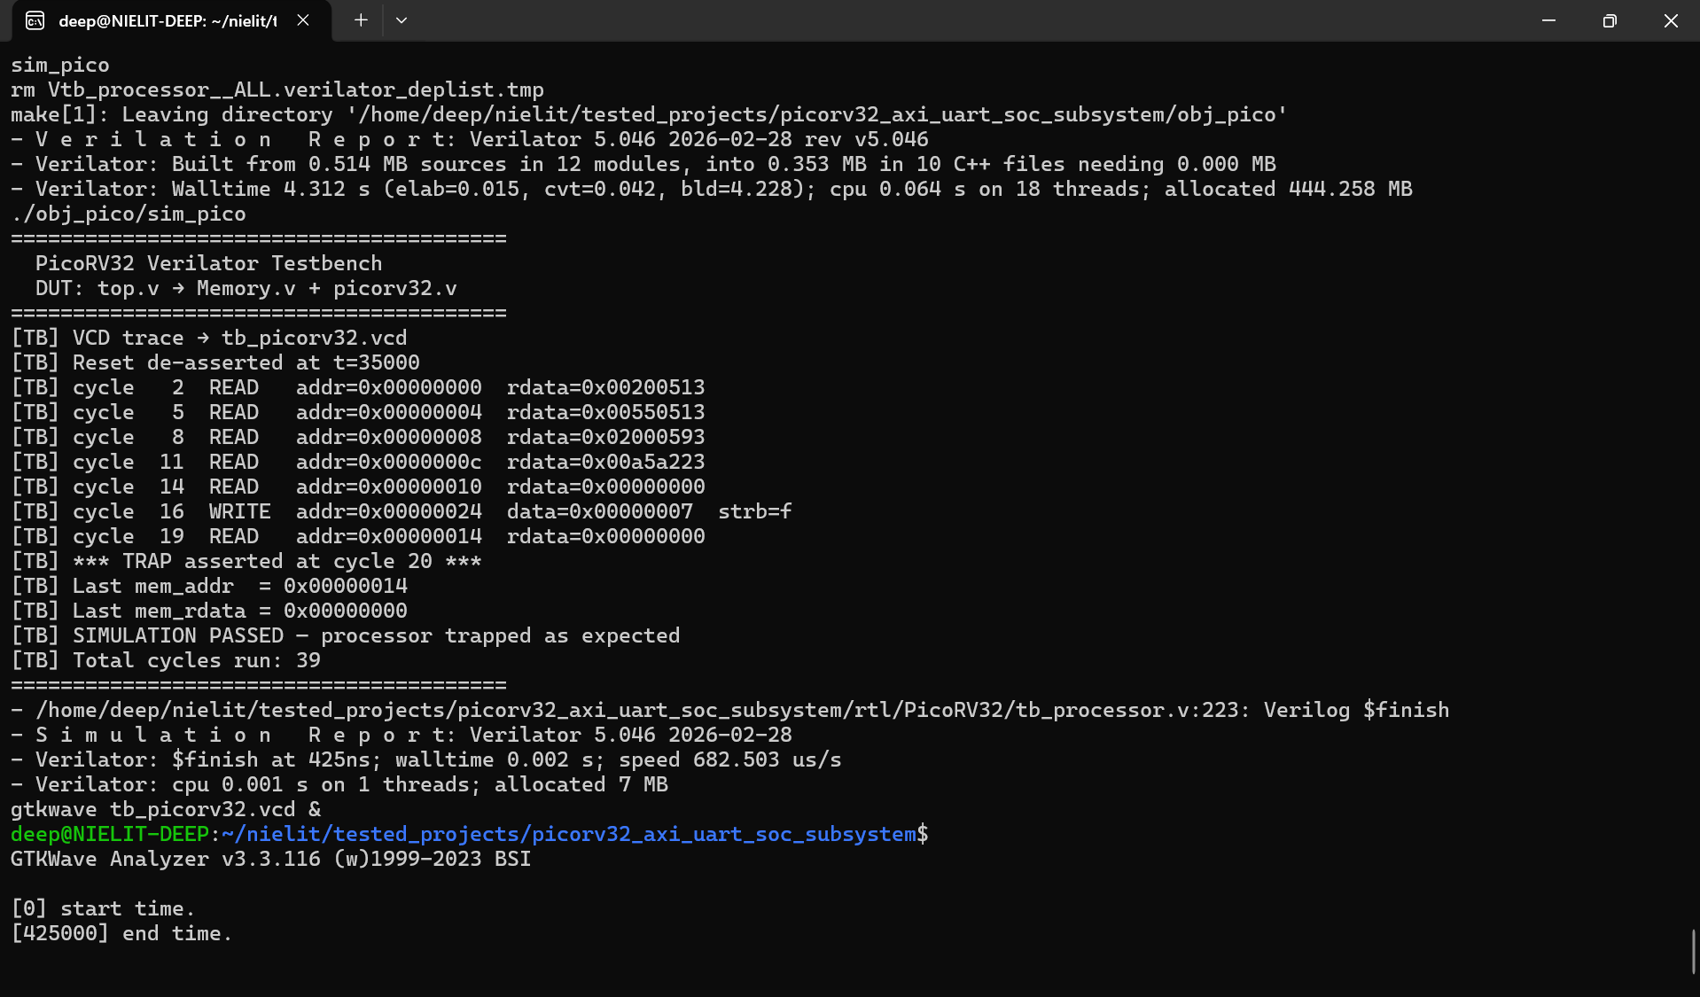

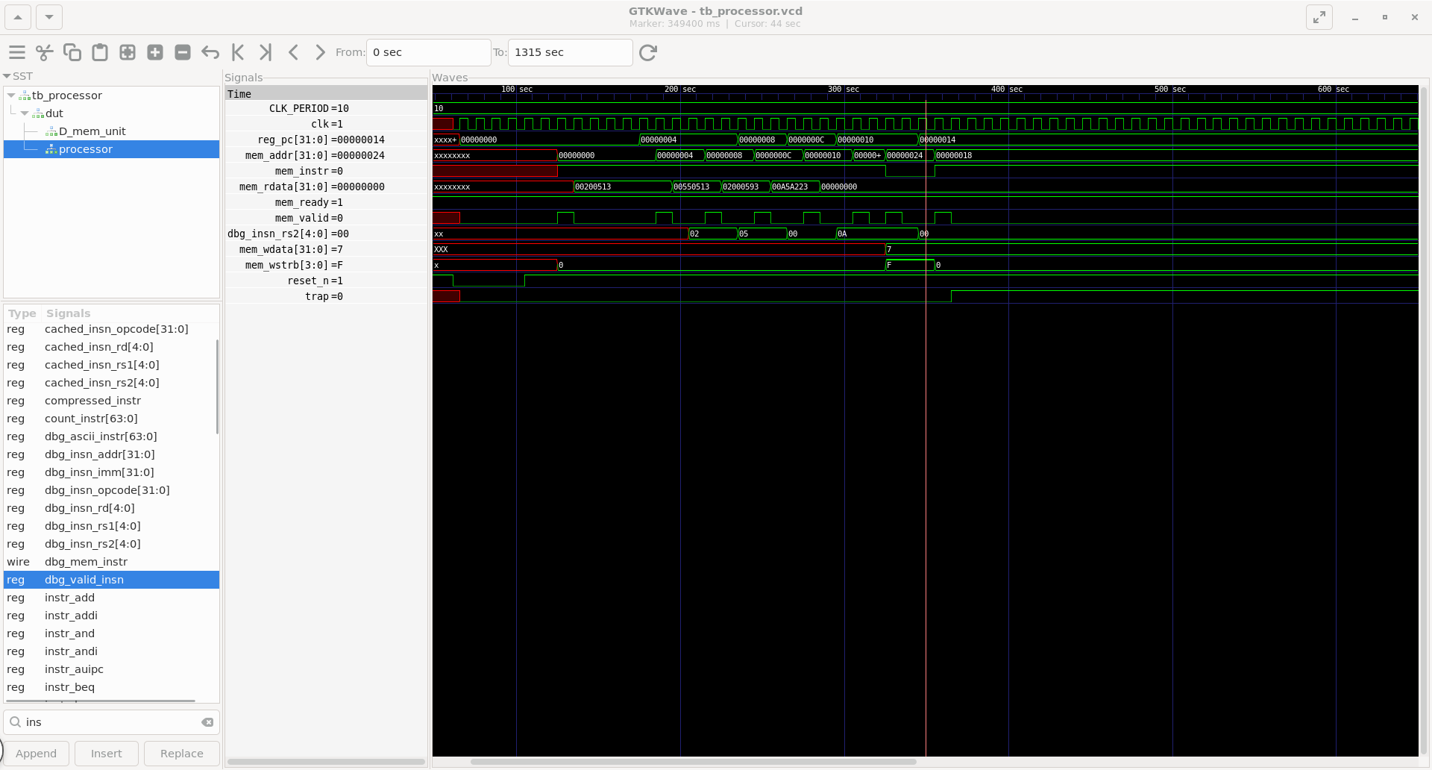

- The assembly code initializes register a0 with 2, next instruction add a0, 5 and save result to register a0 which updates it to 7 using addi instructions.
- Register a1 is loaded with base address 0x20, and the value in a0 is stored at memory location 0x24 using sw.
- The assembly program is compiled using the RISC-V GCC toolchain to generate a .hex file.
- This .hex file is loaded into the PicoRV32 instruction memory (ROM) for execution.
- Waveform analysis verifies correct instruction execution, register updates, and memory write operation.
- PC Increment: The program counter should step from the ROM base address (e.g., 0x00000000) in increments of 4 per instruction, assuming no branches are taken. In waveform view, the pc signal should show a staircase pattern rising by 4 each time mem_ready is received.
- Instruction Fetch: The mem_valid signal should pulse high at the start of each instruction fetch. The mem_addr should correspond to the current PC value. After one clock, mem_ready goes high and the instruction word appears on mem_rdata.
- Register Updates: Though internal register file contents are not directly visible in most waveform exports, debug signals (trap, eoi, or internal wires) can be added to track execution state.
- Memory Writes: When a SW instruction executes, mem_valid goes high, mem_wstrb shows the byte enable pattern (0xF for word write, 0x3 for half-word, 0x1 for byte), and mem_wdata carries the value being written.
- Branch Taken: After a BEQ that evaluates to true, the PC should jump to the branch target address rather than incrementing by 4. This is visible as a non-sequential value appearing on the mem_addr bus.

Practical Note: A common debugging issue in PicoRV32 simulation is the firmware not loading correctly due to endianness mismatch in the hex file or an incorrect memory initialization script. Always verify that the first 4 bytes of the waveform mem_rdata output match the first instruction in the firmware disassembly output of riscv32-unknown-elf-objdump.

AXI-Lite Interconnect Explanation and Verification

5.1 AXI Protocol
AXI is a high-performance AMBA bus protocol widely used in SoC design for efficient data transfer with support for advanced transactions. AXI-Lite is a simplified version that removes burst and multi-transaction features, making it ideal for simple, low-overhead, register-based communication between CPU and peripherals in embedded systems.

5.2 AXI-Lite Channels
AXI-Lite defines five independent channels, each with its own VALID and READY handshake. A transaction completes on a channel when both VALID (driven by the source) and READY (driven by the sink) are simultaneously high for one clock cycle.
- AXI-Lite uses five independent channels, each with VALID/READY handshake; transfer completes when both are high.
- Write Address (AW): Master sends address (AWADDR, AWVALID), slave responds with AWREADY.
- Write Data (W): Master sends data (WDATA, WSTRB, WVALID), slave accepts with WREADY.
- Write Response (B): Slave returns status (BRESP, BVALID), master acknowledges with BREADY.
- Read Address (AR): Master sends read address (ARADDR, ARVALID), slave responds with ARREADY.
- Read Data (R): Slave sends data (RDATA, RVALID, RRESP), master accepts with RREADY.

5.3 AXI-Lite Verification

Individual AXI Testbench Structure
The AXI interconnect testbench (tb_axi.v) verifies the bus fabric independently from the CPU and peripherals. It instantiates the AXI interconnect module along with simple behavioral slave models for each peripheral address region. The testbench drives AXI master transactions directly, simulating what the CPU would do, without needing a full CPU model.
The testbench contains directed test sequences including:
- Write Transaction Test: Assert AWVALID with a specific peripheral address, then WVALID with data and strobe, observe BVALID response, assert BREADY to complete.
- Read Transaction Test: Assert ARVALID with a peripheral address, wait for ARREADY, then assert RREADY and capture the RDATA returned.
- Address Decode Test: Send transactions to each peripheral's address range and verify that the correct slave responds. Transactions to unmapped addresses should return DECERR or SLVERR.

Expected Waveform Behavior

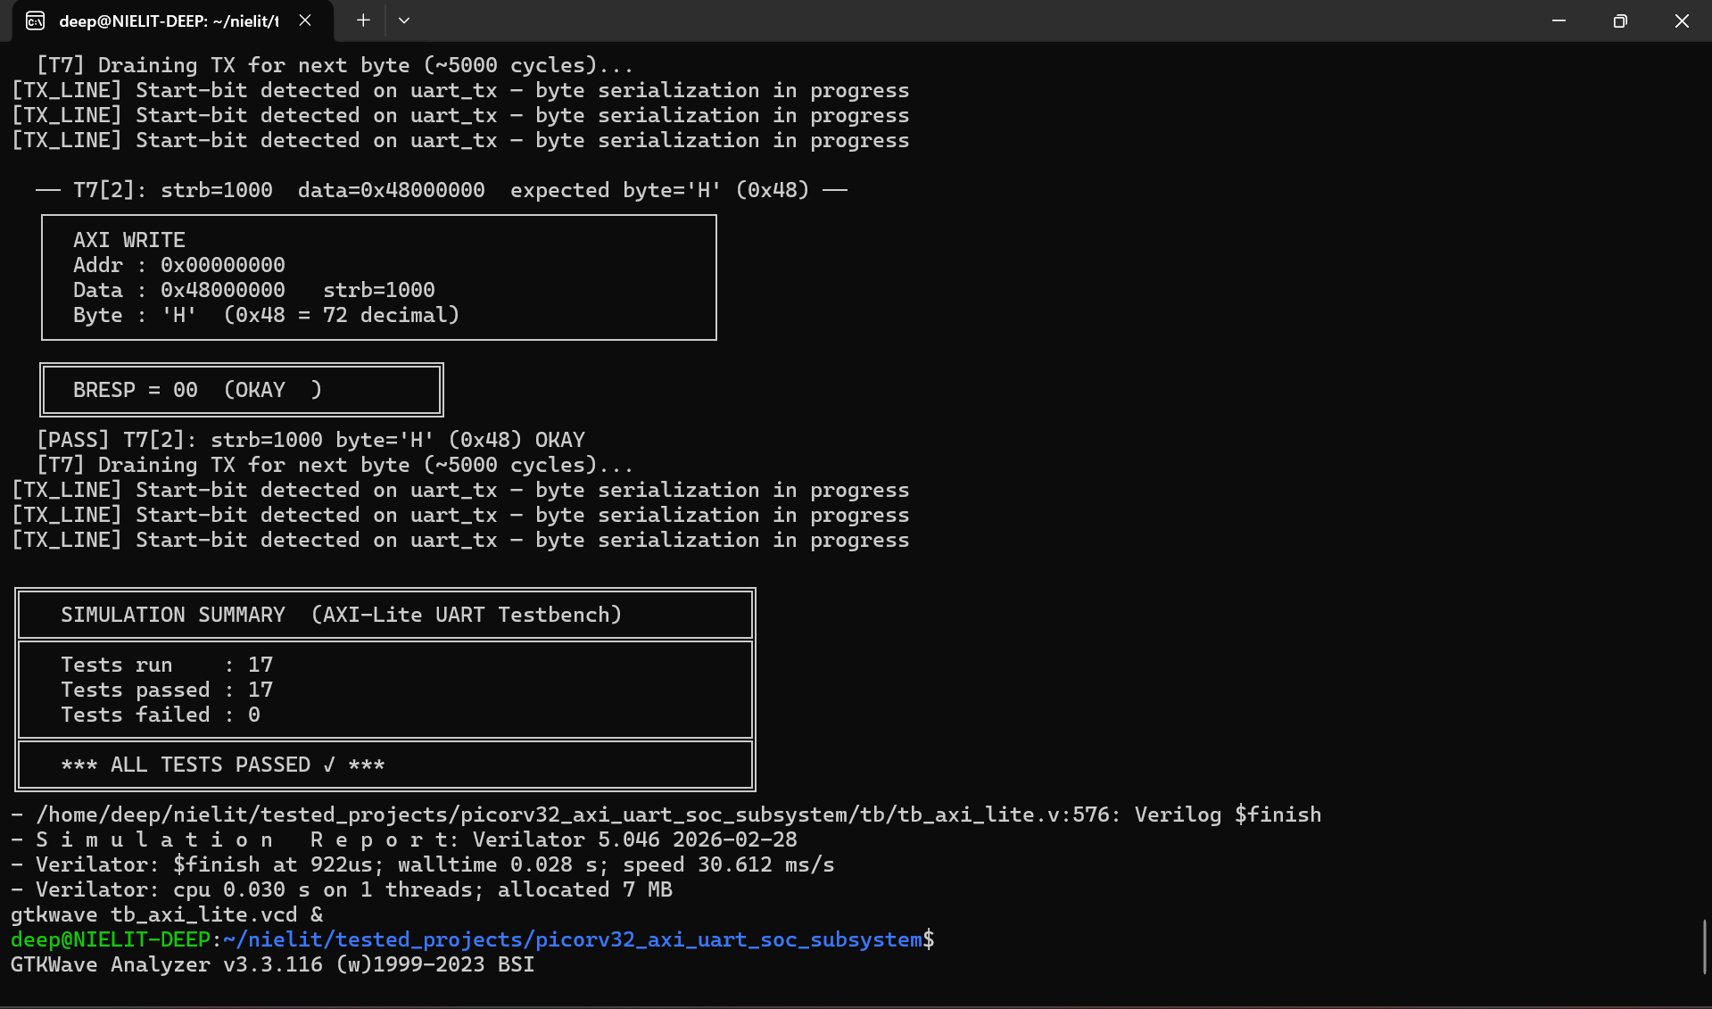

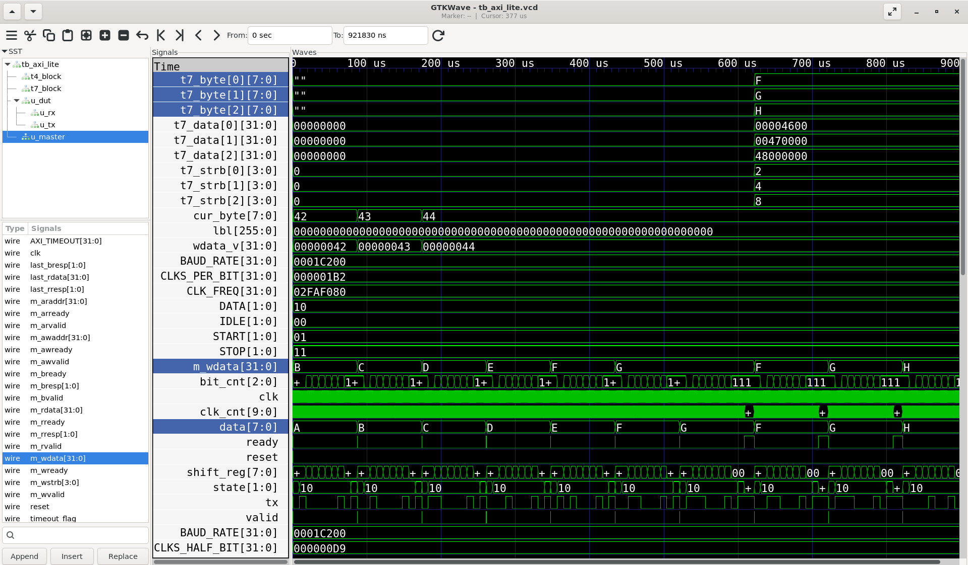

- When the AXI testbench simulation VCD is opened in GTKWave, the following waveform sequences should be visible:
- The AXI-Lite standalone testbench validates correct master–slave communication with multiple read/write transactions to the UART AXI interface.
- Write operations successfully transmit ASCII values A (0x41), B (0x42), C (0x43), and D (0x44) to the TX register, with all transactions showing valid handshake (valid/ready) and BRESP = OKAY.
- Back-to-back writes confirm continuous data transfer capability, while correct byte-lane selection (wstrb) ensures proper placement of transmitted data.
- Read operations from STATUS and DATA registers return RRESP = OKAY and correctly indicate RX buffer status (empty).
- Backpressure is observed when awready goes LOW during TX buffer busy condition, validating flow control.
- Waveform analysis confirms correct AXI handshaking, data transfer, and UART transmission sequence, with all 17 test cases passing successfully.

Practical Note: In AXI-Lite simulation, it is important to ensure that the master does not issue back-to-back transactions faster than the slave can accept them. A common simulation bug is asserting AWVALID while the previous transaction's BVALID has not yet been acknowledged. This causes the slave to receive an address it is not ready to process, leading to incorrect write behavior that can be difficult to spot without careful waveform analysis.

UART Peripheral Explanation and Verification

6.1 UART Basics
UART is a simple, widely used asynchronous serial communication protocol that does not require a shared clock, making it ideal for chip-to-chip and PC communication. It operates in full-duplex using TX and RX lines, transmitting data as a serial bit stream at a fixed baud rate (e.g., 9600, 115200).
- TX Operation: When firmware writes data, UART sends it serially with start bit (0), 8 data bits (LSB first), and stop bit (1), while idle state remains high.
- Framing: Sequence is Idle (1) → Start (0) → Data bits → Stop (1), each lasting one baud period.
- RX Operation: UART detects start bit (falling edge) and samples data at the center of each bit for reliability.
- Data Handling: After receiving 8 bits and validating stop bit, data is stored in RX register/FIFO for firmware access.
- Baud rate: defines bit duration; for 115200 baud, each bit lasts ~8.68 µs. Baud rate generator uses a clock divider (e.g., 50 MHz / 115200 ≈ 434 cycles per bit).

6.2 UART Verification

Individual UART Testbench Structure
The UART testbench (tb_uart.v) verifies the UART peripheral module in isolation. It instantiates the UART RTL module and directly drives its AXI slave interface with write transactions targeting the TX data register. It also optionally loops the TX output back to the RX input to verify the receive path.
The testbench performs the following directed tests:
- Baud Rate Configuration: Write the correct divisor value to the baud rate register via AXI.
- Single Byte Transmission: Write a known ASCII character (e.g., 0x68 = 'h') to the TX data register and observe the serial output on the uart_tx pin.
- Multiple Byte Transmission: Write a sequence of bytes (e.g., "Hello") and verify that each byte is transmitted in sequence with correct framing.
- Loopback Test: Connect uart_tx to uart_rx and verify that transmitted bytes appear in the RX FIFO register.

When the UART testbench waveform is opened in GTKWave, the uart_tx signal should display the following bit-level pattern for the transmission of the byte 0x68 (binary 01101000) at the configured baud rate:

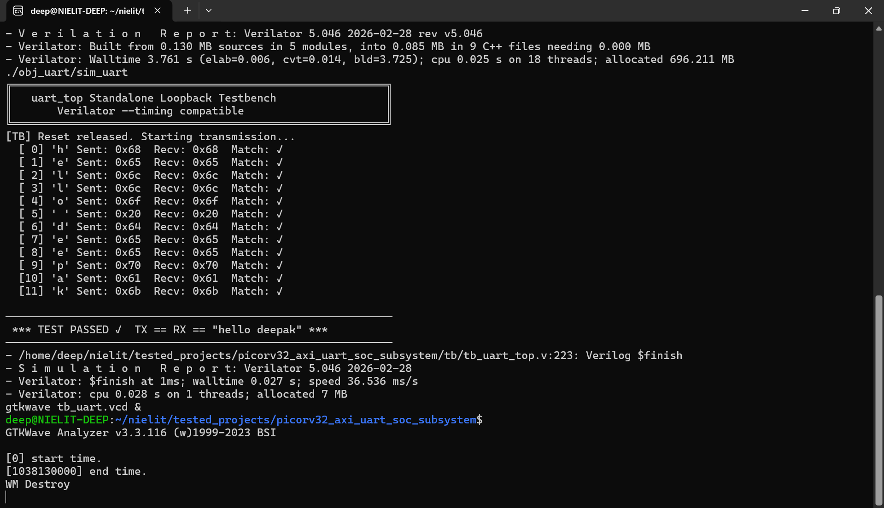

Waveform Analysis: Start Bit, Data Bits, Stop Bit
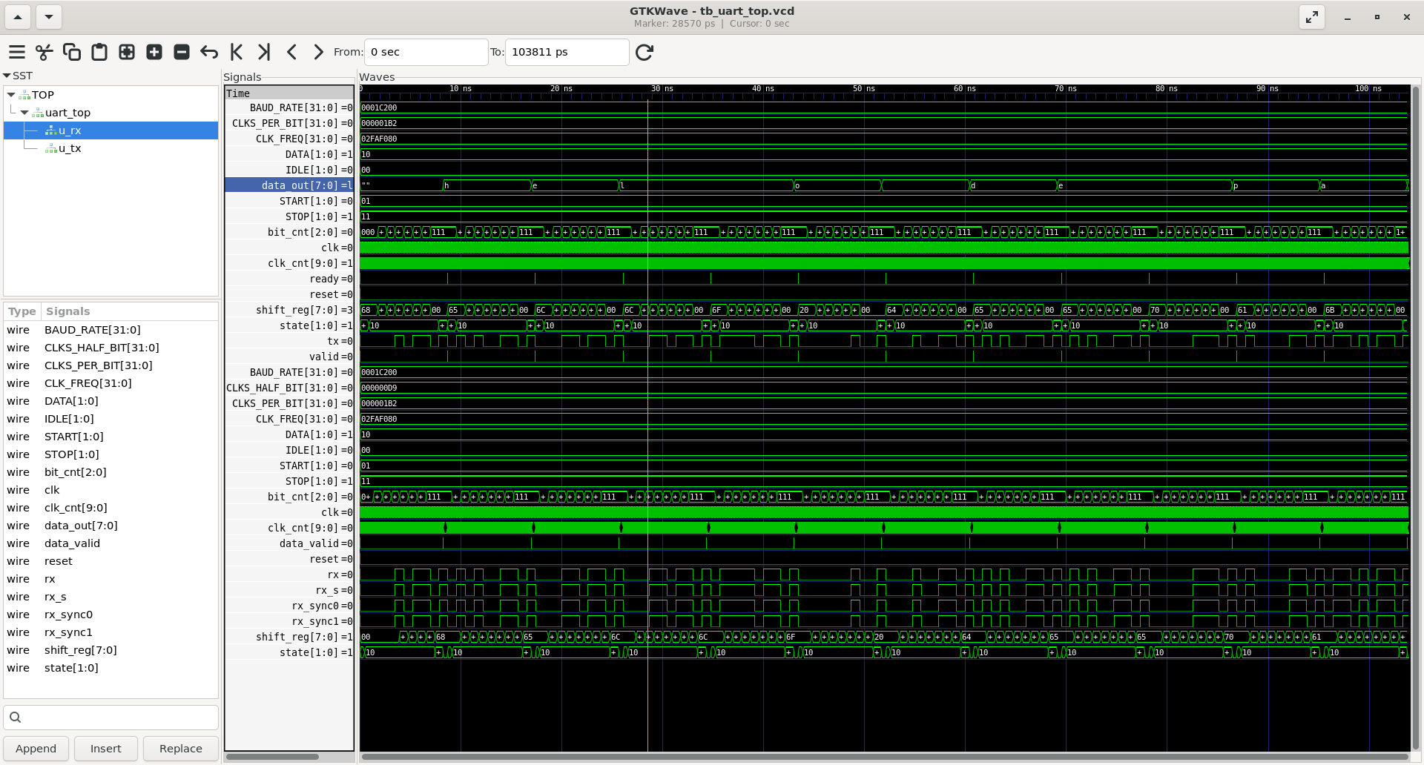
- The UART standalone loopback testbench validates end-to-end serial communication by transmitting the string "hello deepak" (12 bytes) from TX and receiving it back through RX via a hardware loopback.
- Each transmitted ASCII character (e.g., 'h' = 0x68, 'e' = 0x65, 'l' = 0x6C, etc.) is correctly received with exact value matching, confirming accurate serialization and deserialization.

- The system operates at 50 MHz clock with 115200 baud rate (434 clocks/bit), ensuring correct timing of start bit, data bits, and stop bit in the waveform.
- Waveform analysis shows proper UART behavior including start bit detection, sequential bit shifting, and valid data capture at the receiver.
- All 12 bytes are successfully transmitted and received with zero errors, confirming reliable UART functionality and correct integration of TX and RX modules.

In GTKWave, zoom into the uart_tx waveform to the resolution of individual bit periods. Each bit should be exactly (clock_period x baud_divisor) wide. The falling edge of the start bit is the primary reference point. Use GTKWave markers to measure the period of each bit and verify it matches the expected baud period.

Practical Note: A common waveform debugging issue with UART is a timing offset between when firmware writes to the TX register and when the TX waveform begins. This is caused by the UART TX FIFO having a non-zero latency before serialization begins. In waveforms, look for the AXI write transaction to the TX register completing, followed by a short delay (typically 1-4 clock cycles) before the uart_tx start bit falls.

Tools Used

7.1 Verilator
In this project, Verilator is used for the primary simulation flow. The RTL files (top.v, picorv32.v, axi_interconnect.v, uart.v) are compiled by Verilator along with a C++ testbench wrapper (sim_main.cpp). The wrapper loads the firmware hex file, instantiates the top-level RTL model, drives clock and reset signals, and dumps simulation waveforms to a VCD file.

7.2 GTKWave
In this project, GTKWave is used to open the VCD file generated by the Verilator simulation. Key operations in GTKWave include adding signals from the signal hierarchy panel to the waveform view, zooming in to specific time ranges, placing measurement markers.

7.3 RISC-V GCC Toolchain
The riscv32-unknown-elf-gcc toolchain is the cross-compiler used to compile C and assembly firmware for the RISC-V target. It runs on the host machine (Linux/macOS/Windows) and generates RV32I binary output. The toolchain consists of several components:
- gcc: C compiler frontend that takes C source code and produces RISC-V assembly or object code.
- as: Assembler that converts assembly source (.s) to relocatable object files (.o).
- ld: Linker that combines object files and a linker script to produce the final ELF binary.
- objcopy: Converts the ELF binary into raw binary or Intel hex format for simulation ROM loading.
- objdump: Disassembles the ELF binary, showing the human-readable assembly corresponding to each address. Essential for firmware debugging and waveform cross-reference.

7.4 Makefile
A Makefile automates the multi-step simulation flow, reducing it to simple make commands.
• make / make help → Display all available commands
• make fw → Build firmware
• make uart → Run UART testbench
• make axilite → Run AXI-Lite testbench
• make pico → Run PicoRV32 testbench
• make soc → Run full SoC sim (CPU + UART + AXI + memory)
• make wave → View waveform
• make synth → Perform RTL synthesis using Yosys
• make clean → Remove all generated files

Design Implementation

8.1 Project Folder Structure
The project repository is organized into a clean, modular directory structure that separates RTL source code, testbench files, and firmware source code. This separation is a standard practice in professional SoC design environments and makes the project easier to navigate, maintain, and extend.
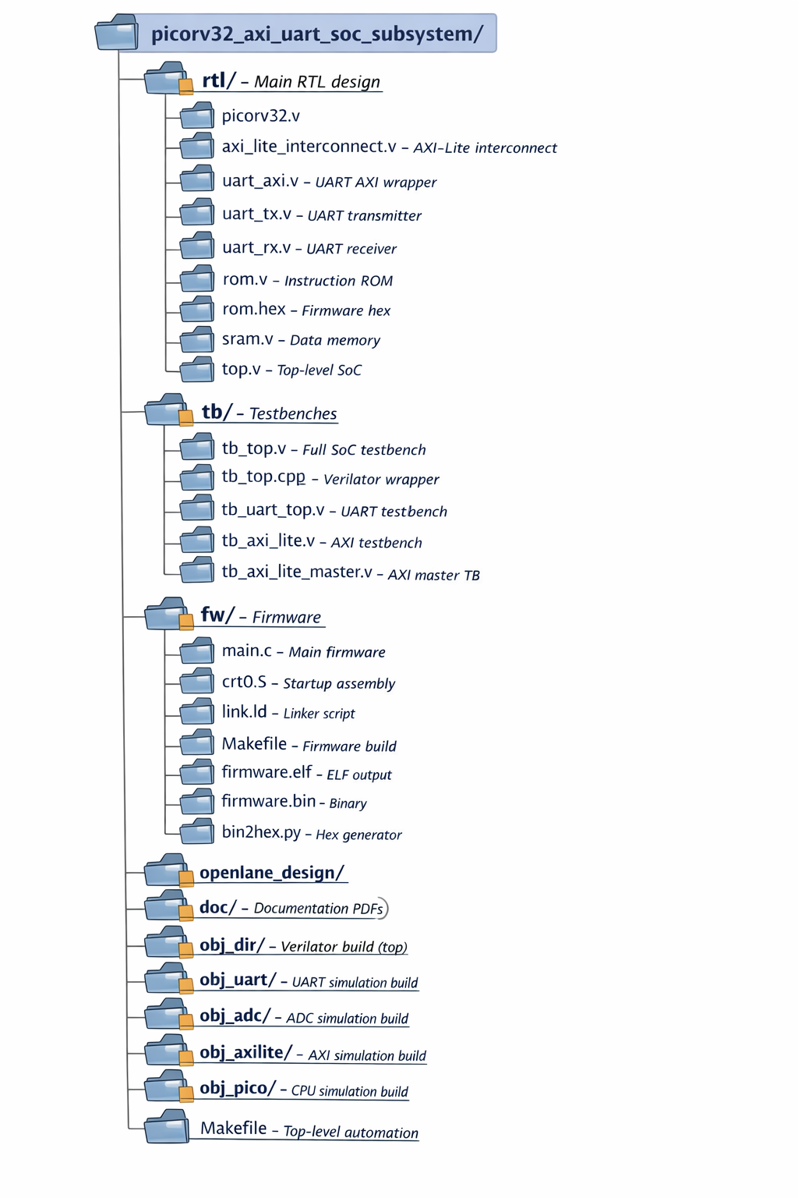

8.2 RTL Module Descriptions
top.v
The top.v module is the integration wrapper that instantiates and connects all RTL submodules into the complete SoC subsystem. Its signal list includes the system clock (clk), active-low or active-high reset (rst), and the external UART pins (uart_tx, uart_rx). All internal signal connections between the CPU, interconnect, ROM, SRAM and UART modules are made within top.v using wire declarations.
picorv32.v
The picorv32.v file contains the complete PicoRV32 RISC-V core as obtained from the official open-source repository. Key parameters that may be configured include ENABLE_COUNTERS (enables the performance counter CSR instructions), BARREL_SHIFTER (enables single-cycle barrel shifter instead of multi-cycle shift). The module exposes the mem_* interface signals for external memory connection.
axi_lite_interconnect.v
The axi_lite_interconnect.v module implements a simple static AXI-Lite address decoder and bus router. It takes the CPU memory interface signals as inputs, converts them into AXI-Lite master transactions, decodes the address to select the appropriate slave, and connects the selected slave's AXI interface to the transaction.
uart_axi.v
The uart_axi.v module implements the UART peripheral with an AXI-Lite slave interface. It contains memory-mapped registers such as baud rate divisor, TX data, RX data, and status registers. It acts as a bridge between the AXI bus and the UART TX/RX logic.
uart_tx.v
The uart_tx.v module implements the UART transmitter. It serializes parallel data into a serial bit stream using start bit, 8 data bits (LSB first), and stop bit at the configured baud rate.
uart_rx.v
The uart_rx.v module implements the UART receiver. It samples incoming serial data, reconstructs the byte by sampling at the center of each bit period, and makes the received data available to the system.
rom.v
The rom.v module implements the instruction ROM using a Verilog reg array. The memory is initialized using $readmemh with the rom.hex file path at the start of simulation. It implements a simple synchronous read interface compatible with the AXI-Lite or native PicoRV32 memory interface.
rom.hex
The rom.hex file contains the firmware program in hexadecimal format, generated from compiled assembly or C code, and is loaded into ROM during simulation.
sram.v
The sram.v module implements the data SRAM using a reg array with byte-enable support. Write operations check the wstrb byte-enable signals to update only the enabled bytes within each word. This is essential for correct implementation of SB (store byte) instructions from the RISC-V ISA.

The integration follows this signal flow:
- PicoRV32 core memory interface outputs (mem_valid, mem_addr, mem_wdata, mem_wstrb) connect to the AXI interconnect master inputs.
- AXI interconnect master outputs (mem_ready, mem_rdata) connect to PicoRV32 memory interface inputs.
- AXI interconnect slave interfaces for ROM, SRAM and UART connect to the respective module ports.
- UART TX and RX pins are brought out to the top-level port list for external connection.
- All modules share the common clk and rst signals.

Simulation Flow (Step-by-Step)

9.1 Firmware Generation
The first step in the simulation flow is generating the firmware binary that will be loaded into the ROM for CPU execution. This is done using the RISC-V GCC toolchain from the fw/ directory.
The build process is initiated with:
make clean
make fw
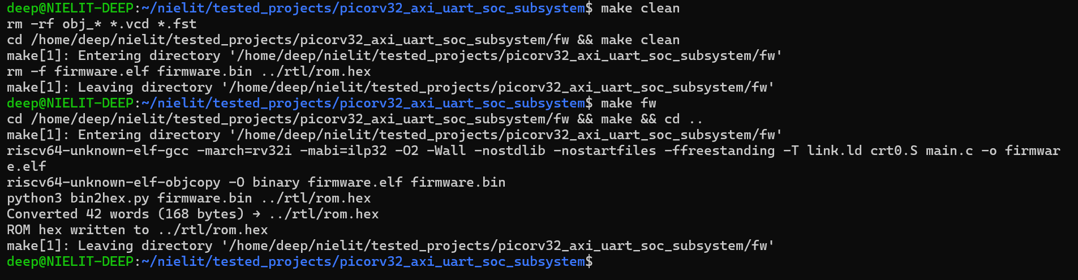
This target executes the following steps internally:
- Compilation: riscv32-unknown-elf-gcc compiles firmware.c and start.s with flags -march=rv32i -mabi=ilp32 -nostdlib -nostartfiles to target the RV32I ISA without any standard library or OS support.
- Linking: The linker combines the compiled object files using the link.ld linker script, which specifies that the .text section (code) starts at 0x00000000 (ROM base) and the .data section starts at 0x00010000 (SRAM base).
- Binary Extraction: riscv32-unknown-elf-objcopy extracts the raw binary from the ELF file and writes it in Intel hex format to fw/rom.hex.
- Disassembly (optional): riscv32-unknown-elf-objdump -d firmware.elf generates a human-readable disassembly that shows each instruction's address and mnemonic, which is essential for correlating with the simulation waveform.

9.2 Running the Simulation
The project uses a Makefile for Full SoC subsystem simulation, verification.
• make clean → Remove all generated files
• make soc → Run full SoC sim (CPU + UART + AXI + memory)
Or use
rm -rf obj_dir/
cd fw && make && cd .. && \
verilator --binary -j 0 -Wall \
--trace \
--timing \
--top tb_top \
-Mdir obj_dir \
-o sim_verilator \
-Wno-fatal \
-Wno-WIDTHTRUNC \
-Wno-WIDTHEXPAND \
-Wno-PROCASSINIT \
-Wno-CASEINCOMPLETE \
-Wno-UNOPTFLAT \
-Wno-INITIALDLY \
-Wno-MULTITOP \
-Wno-DECLFILENAME \
-Wno-GENUNNAMED \
-Wno-UNUSEDSIGNAL \
-Wno-EOFNEWLINE \
-Wno-PINCONNECTEMPTY \
-Wno- PINMISSING \
-Wno-BLKSEQ \
rtl/picorv32.v \
rtl/uart_tx.v \
rtl/uart_rx.v \
rtl/uart_axi.v \
rtl/rom.v \
rtl/sram.v \
rtl/axi_decoder.v \
rtl/axi_lite_interconnect.v \
rtl/top.v \
tb/tb_top.v && \
./obj_dir/sim_verilator +romhex=rtl/rom.hex && \
vcd2fst tb_top.vcd tb_top.fst && \
gtkwave tb_top.fst

Manual Run Script In “Run_Uart_AXI-LITE_PicoRV32.txt”
The file contains all commands to simulate and run the project without using the Makefile.
- Organized into sections: UART, AXI-Lite, PicoRV32, Full SoC and synthesis
- Each section includes clean, compile (Verilator), run, and waveform viewing steps
- Supports both C++ and Verilog testbench flows (primarily Verilog in this project)
- Firmware is built separately and loaded using `rom.hex`
- Enables independent module testing and full SoC verification
The file provides a complete manual workflow for simulation, debugging, and ASIC flow execution without automation.
After generating the firmware hex file, the full SoC simulation is executed using:
make soc

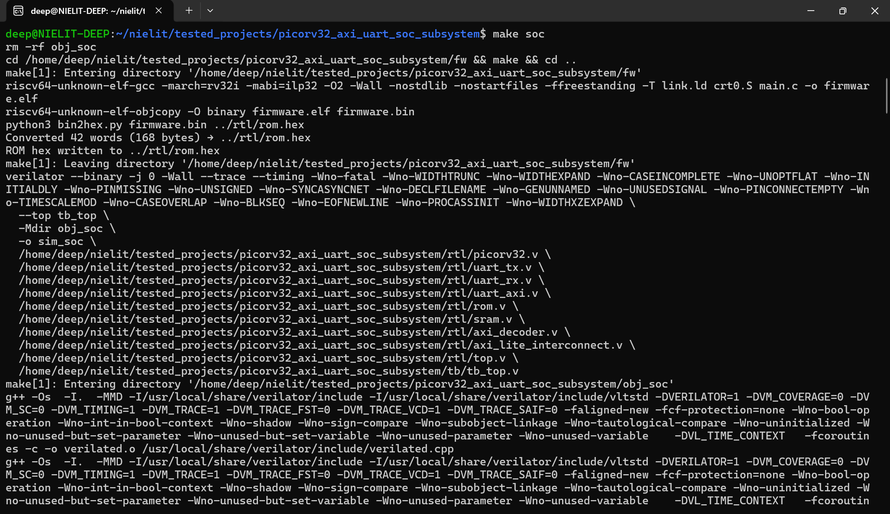

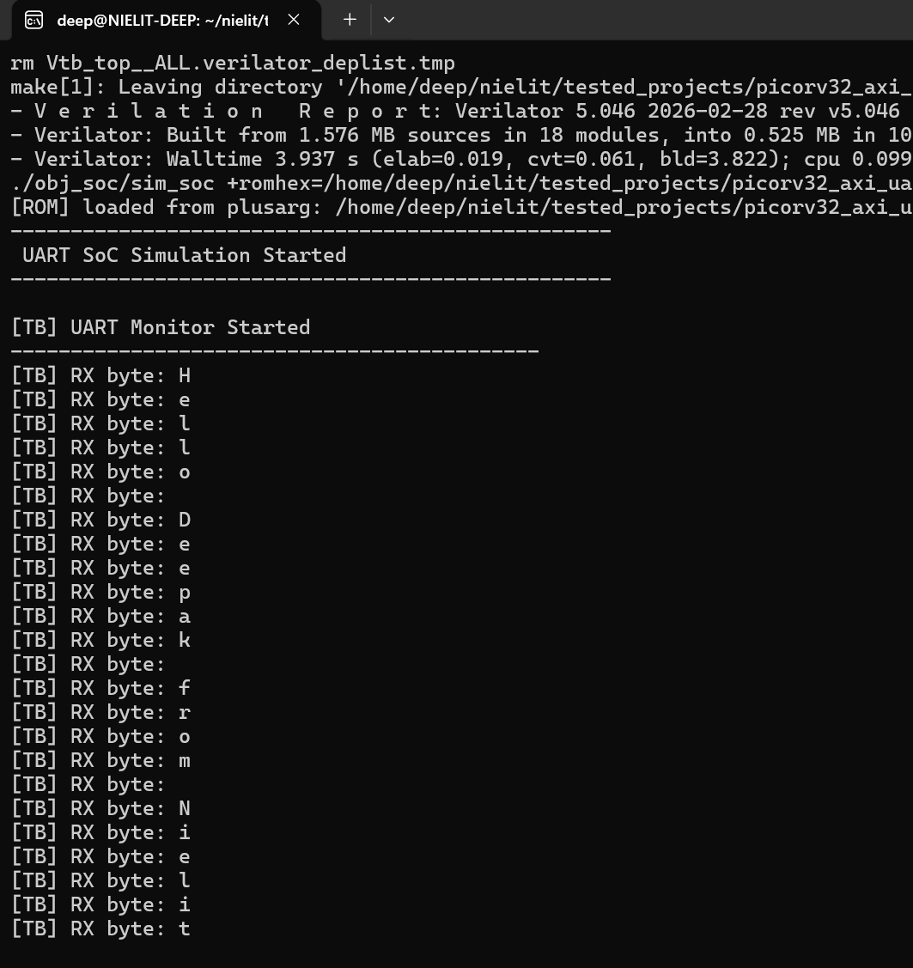

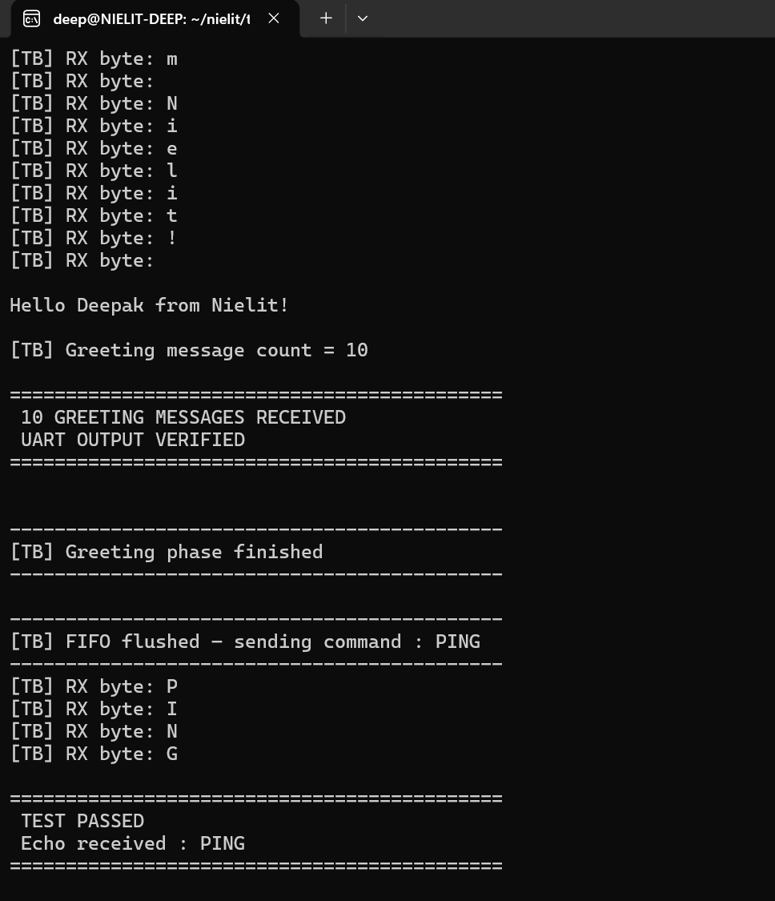
This performs the following steps:
- Verilator Compilation: Verilator compiles all RTL modules (picorv32, UART, AXI interconnect, ROM, SRAM, top) along with the Verilog testbench tb_top.v into a cycle-accurate simulation model.
- C++ Model Generation: Verilator automatically generates internal C++ files (e.g., Vtb_top.cpp, Vtb_top__ALL.cpp) inside the obj_soc/ directory.
- Binary Build: These files are compiled using g++ to create the simulation executable (sim_soc).
- Simulation Execution: The executable is run with the firmware hex file passed as a plusarg: ./obj_soc/sim_soc +romhex=rtl/rom.hex

9.3 Internal Simulation Data Flow
Understanding the internal data flow during simulation, the following sequence occurs:
- Firmware Load: The ROM module reads rom.hex using $readmemh, initializing instruction memory.
- Reset Phase: The testbench asserts reset for initial cycles, clearing CPU and interconnect state.
- Instruction Fetch: After reset, PicoRV32 starts fetching instructions from ROM via AXI-Lite read transactions.
- Execution: The CPU executes firmware, generating AXI read/write transactions to SRAM and peripherals.
- UART Operation: Firmware writes characters to UART TX register, producing serial output on uart_tx.
- Testbench Monitoring: The Verilog testbench (tb_top.v) monitors UART output and validates functionality.
From your simulation:
- Greeting messages are transmitted and verified
- UART loopback (PING → PING) is tested
- Testbench prints TEST PASSED after successful verification

9.4 Waveform Generation and Viewing
The VCD file generated by the simulation can be opened in GTKWave using:
make wave
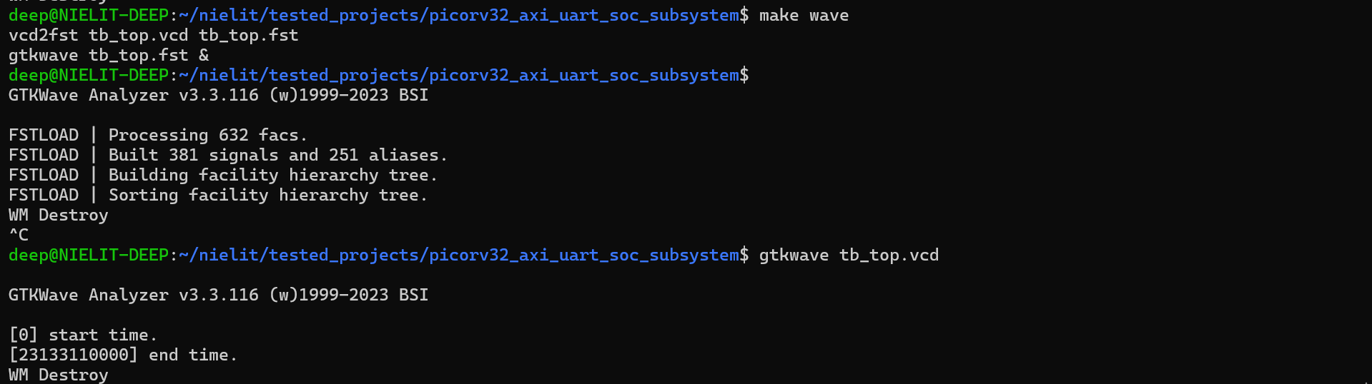
or equivalently:
gtkwave tb_top.vcd &


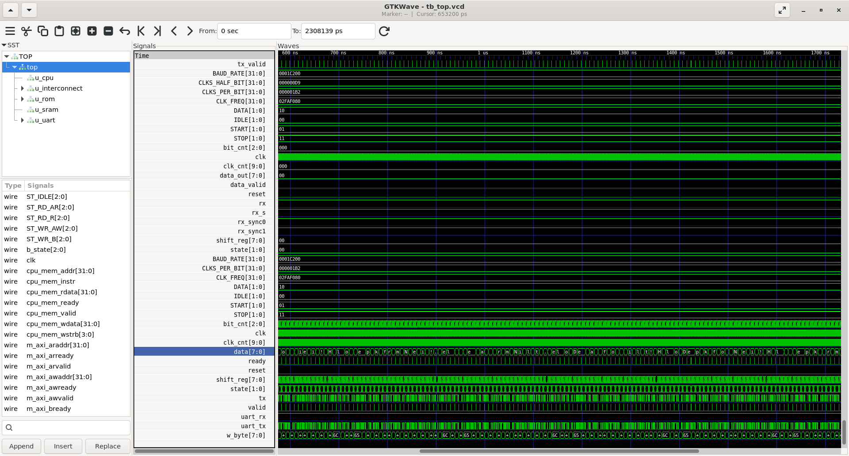
1. Clock and Reset Initialization
- clk signal toggles continuously with a fixed period (≈50 MHz).
- reset is asserted (active high) for initial cycles → all modules are initialized.
- During reset:
  - CPU Program Counter (PC) is held at reset value
  - Registers and internal states are cleared
- After reset deassertion → system begins normal operation

2. CPU Instruction Fetch Phase
- Signals involved:
  - mem_valid → indicates memory request
  - mem_addr → address of instruction/data
  - mem_rdata → instruction fetched from ROM
  - mem_ready → memory response
- Behavior observed:
  - CPU asserts mem_valid
  - ROM responds with instruction (mem_rdata)
  - PC increments by 4 for each instruction
3. Instruction Execution Phase
- CPU decodes and executes instructions:
  - Arithmetic operations (ADD, ADDI)
  - Memory access (load/store)
  - Peripheral access (UART write)
- AXI-Lite interconnect routes:
  - ROM → instruction fetch
  - SRAM → data operations
  - UART → peripheral writes
- Visible in waveform:
  - Address changes (mem_addr)
  - Write strobes (mem_wstrb) for store operations.

4. UART Transmission (TX) Behavior
- Signal: uart_tx
- Idle condition:
  - Line remains HIGH (logic 1)
- For each transmitted byte:
  - Start bit → LOW (0)
  - 8 data bits → LSB first
  - Stop bit → HIGH (1)
- Bit timing:
  - Controlled by baud rate generator (~115200 baud)
  - Each bit spans multiple clock cycles
- Waveform pattern:
  - Repeating serial pulses → corresponds to characters
- Actual transmitted message:
Hello Deepak from Nielit!
- Repeated multiple times (as per firmware logic)

5. UART Monitor (Testbench Operation)
- Testbench continuously monitors uart_tx
- Detects falling edge → start bit
- Samples bits at center of baud period
- Reconstructs bytes and stores in FIFO
- Additional behavior:
  - Counts number of received messages
  - Prints received characters to console
  - Confirms correct UART transmission
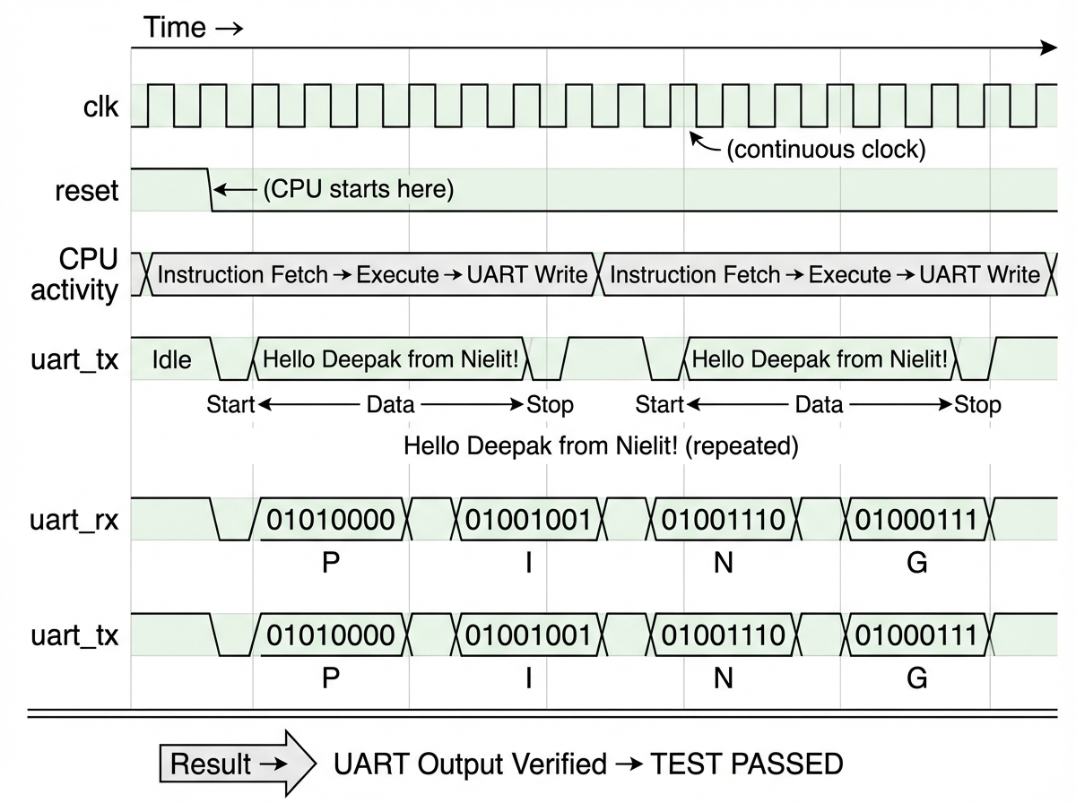

6. Greeting Message Verification
- Firmware prints greeting message repeatedly
- Testbench counts messages using newline detection
- Observed behavior:
  - Message received 10 times
  - Testbench prints: 10 GREETING MESSAGES RECEIVED
UART OUTPUT VERIFIED
  - Confirms: CPU execution correct, UART TX working correct.

7. UART Reception (RX) Phase
- Signal: uart_rx
- After greeting phase:
  - Testbench sends command: PING
- UART RX logic:
  - Detects start bit
  - Samples incoming bits
  - Reconstructs byte
  - Passes data to CPU via AXI

8. Loopback / Echo Verification
- Firmware receives "PING"
- CPU processes input
- Sends response via UART TX
- Observed waveform:
  - RX activity followed by TX activity
  - Same bit pattern appears on TX
- Output:
PING → PING
- Testbench verifies response and prints:
TEST PASSED

9. AXI-Lite Communication Behavior
- CPU accesses peripherals via AXI-Lite:
  - Write to UART TX register
  - Read from UART RX register
- Signals observed:
  - Address phase (AW/AR)
  - Data phase (W/R)
  - Handshake (VALID/READY)
- Confirms:
Proper bus communication
Correct peripheral mapping

10. Simulation Termination
- Simulation ends when:
  - Testbench verifies all conditions
  - $finish is triggered
- No timeout or error observed

Applications

10.1 Embedded Systems
The PicoRV32-based SoC subsystem is directly applicable in embedded systems design. Microcontrollers based on RISC-V are increasingly being adopted in industrial control units, sensor data acquisition systems, and motor drive controllers. The open-source nature of RISC-V makes it possible to customize the processor core (adding application-specific instructions), the bus topology, and the peripheral set to exactly match the requirements of the target application without incurring licensing costs.

10.2 IoT Devices
Internet of Things (IoT) devices require processors that are ultra-low-power, compact, and capable of running lightweight communication stacks. PicoRV32 synthesizes to a very small gate count and can be implemented in standard-cell technologies at 28nm or below with sub-milliwatt dynamic power consumption. The UART peripheral provides a communication channel for IoT protocols, and the modular AXI bus allows easy integration of additional IoT peripherals such as I2C, SPI, and wireless modem interfaces.

10.3 Custom SoC Design
For research institutions, fabless semiconductor startups, and government-funded R&D programs (including NIELIT and MeitY initiatives), this project provides a solid foundation for custom SoC development. The modular architecture allows the system to be extended with additional peripherals, accelerators, or co-processors. The verified subsystem can serve as the CPU subsystem in a larger SoC that also includes a GPU, DSP, security engine, or other specialized computational blocks.

10.4 Low-Power Processors
Research into low-power processor architectures leverages RISC-V's minimal base ISA as a starting point. The PicoRV32 core can be modified to include clock gating, power gating, and dynamic voltage and frequency scaling (DVFS) support. Academic researchers can use this SoC project as a verified baseline from which to measure the power and performance impact of various microarchitectural optimizations.

10.5 FPGA Prototyping
The entire SoC subsystem is fully synthesizable and can be targeted to commercial FPGA platforms such as Xilinx Artix-7, Spartan-7, or Intel Cyclone V. FPGA prototyping allows real-world hardware validation of the SoC design at lower cost and shorter turnaround time compared to ASIC tape-out. The UART peripheral enables PC-based debug communication from the FPGA prototype, and the AXI-Lite interconnect is natively supported by FPGA vendor IP integration tools such as Xilinx Vivado IP Integrator.

Conclusion

This project provides a comprehensive, end-to-end learning experience in SoC design and verification using the RISC-V architecture. Through the implementation and simulation of the PicoRV32-based SoC subsystem, the following key competencies have been developed:
- Deep understanding of the RISC-V ISA, instruction encoding, and the relationship between assembly language, machine code, and hardware execution.
- Practical experience with RTL design of processor cores, bus interconnects, and peripheral modules using Verilog.
- Proficiency in SoC-level integration, including signal routing, memory mapping, and interface protocol compliance.
- Hands-on simulation skills using Verilator for compiled RTL simulation and GTKWave for waveform analysis.
- Understanding of individual subsystem verification methodology — isolating and testing each module with dedicated testbenches before full system integration.
- Firmware development skills for embedded RISC-V targets using the open-source GCC toolchain.

